**DUA MIRANI**

**21SW084**

**LAB 05 TASKS**

**TASK#1**

class Operation{

String add(String a,String b){

return a+b;}

float subtract(float a, float b){

return a-b;}

int multiply(int a,int b){

return a*b;}

float division(int a, int b){

return a/b;}}

public class lab05 {

public static void main(String[] args) {

Operation obj = new Operation();

System.out.println(obj.add("dua","mirani"));

System.out.println(obj.subtract(23,12));

System.out.println(obj.multiply(2,4));

System.out.println(obj.division(22,12));

}

}

**OUTPUT**

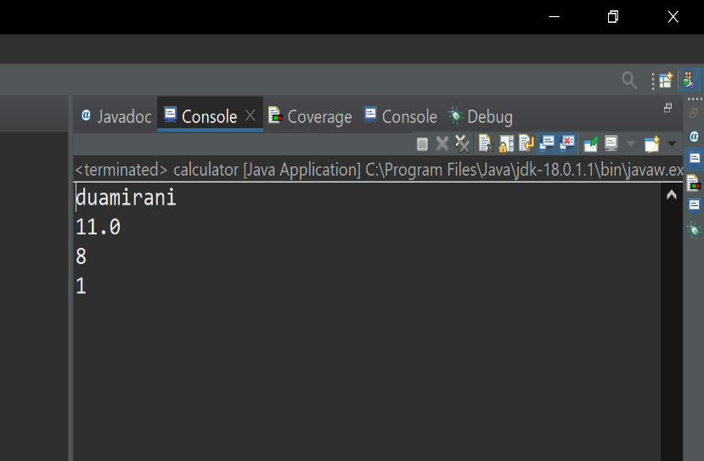

**TASK#2**

|  |
| --- |
| class Car{ |
|  | static int car_issue_number_counter ; |
|  | private String name; |
|  | private String model; |
|  | private String engine_name; |
|  | public void assignIssueNumber(){ |
|  | car_issue_number_counter++; |
|  | this.car_issue_number = car_issue_number_counter; } |
|  | public String getName(){ |
|  | return name; |
|  | } |
|  | public String getModel(){ |
|  | return model; |
|  | } |
|  | public String getEngine(){ |
|  | return engine_name; |
|  | } |
|  | public int getTopSpeed(){ |
|  | return top_speed; |
|  | } |
|  | public int getIssueNumber(){ |
|  | return car_issue_number; |
|  | } |
|  | public void setName(String n){ |
|  | this.name =n; |
|  | } |
|  | public void setModel(String model){ |
|  | this.model =model; |
|  | } |
|  | public void setEngine(String engine){ |
|  | this.engine_name =engine; |
|  | } |
|  | public void setTopSpeed(int top_speed){ |
|  | this.top_speed = top_speed;  }} |
|  | public class Task2 { |
|  | public static void main(String[] args) { |
|  | Car enzoFerrari = new Car(); |
|  | enzoFerrari.setName("Enzo Ferrari 12"); |
|  | enzoFerrari.setModel("1982"); |
|  | enzoFerrari.setEngine("V8 Turbo hybrid"); |
|  | enzoFerrari.setTopSpeed(250); |
|  | enzoFerrari.assignIssueNumber(); |
|  | System.out.println("Name = " + enzoFerrari.getName()); |
|  | System.out.println("Model = " + enzoFerrari.getModel()); |
|  | System.out.println("Engine = " + enzoFerrari.getEngine()); |
|  | System.out.println("Top speed = " + enzoFerrari.getTopSpeed() + "kmh"); |
|  | System.out.println("Issue number = " + enzoFerrari.getIssueNumber()); |
|  | Car gtr = new Car(); |
|  | gtr.setName("Mercedes GTR"); |
|  | gtr.setModel("2019"); |
|  | gtr.setEngine("V12 Turbo hybrid"); |
|  | gtr.setTopSpeed(300); |
|  | gtr.assignIssueNumber(); |
|  | System.out.println("Name = " + gtr.getName()); |
|  | System.out.println("Model = " + gtr.getModel()); |
|  | System.out.println("Engine = " + gtr.getEngine()); |
|  | System.out.println("Top speed = " + gtr.getTopSpeed() + "kmh"); |
|  | System.out.println("Issue number = " + gtr.getIssueNumber());}}  **OUTPUT** |
|  |  |
|  |  |
|  |  |

**TASK#3**

class student{

String student_name,roll_no;

int year;

String qualification;

public student (String qualification){

this.qualification=qualification;}

void set_data(String student_name, String roll_no, int year){

this.student_name=student_name;

this.roll_no=roll_no;

this.year=year;}

void display(){

System.out.println(student_name);

System.out.println(roll_no);

System.out.println(year);

System.out.println(qualification);}}

class lab05{

public static void main(String[] args) {

student obj=new student("intermediate");

obj.set_data("dua","21sw084",18);

obj.display();}

**OUTPUT**

